**Step 1. Project Requirements for Cat Clicker**

**Visuals**

* The application should display a picture of a cat and a number of clicks.
* The specifics of the layout do not matter, so style it however you'd like.

**Interaction**

* The number of clicks should increment when the cat picture is clicked.

**Inspiration**

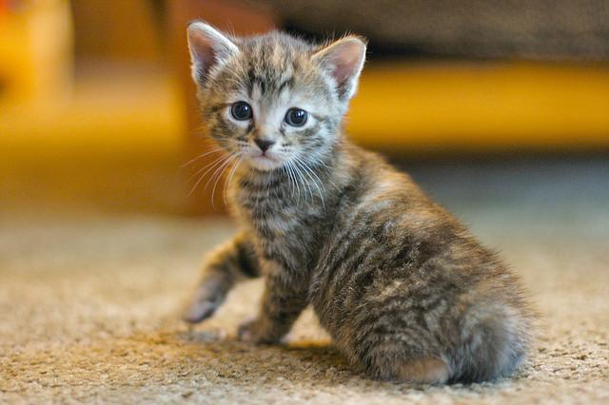

## Step 2. New Project Requirements for Cat Clicker

### Visuals

* The application should display two cats. Each cat includes
  + the cat's name
  + a picture of the cat
  + text showing the number of clicks
* The specifics of the layout do not matter, so style it however you'd like.

### Interaction

* The number of clicks should increment when each cat picture is clicked.

### Inspiration

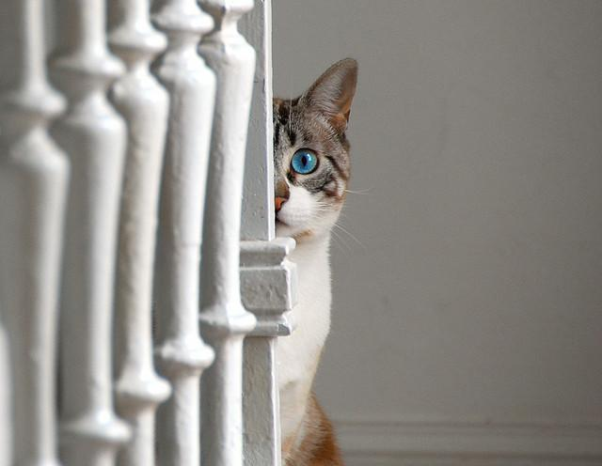

## Step 3. Project Requirements for Cat Clicker Premium

### Visuals

* The application should display
  + a list of at least 5 cats, listed by name
  + an area to display the selected cat
* In the cat display area, the following should be displayed
  + the cat's name
  + a picture of the cat
  + text showing the number of clicks
* The specifics of the layout do not matter, so style it however you'd like.

### Interaction

* When a cat name is clicked in the list, the cat display area should update to show the data for the selected cat.
* The number of clicks in the cat area should be unique to each cat, and should increment when the cat's picture is clicked.

### Inspiration

